Project Design Phase-II
Technology Stack (Architecture & Stack)

Date | 27 June 2026
Team ID: RH-2026 | RH-2026
Project Name: RentalHouse | RentalHouse
Maximum Marks | 4 Marks

Technical Architecture:
The Deliverable shall include the architectural diagram as below and the information as per the table1 & table 2
RentalHouse Technology Stack Layers Diagram (Light Theme):
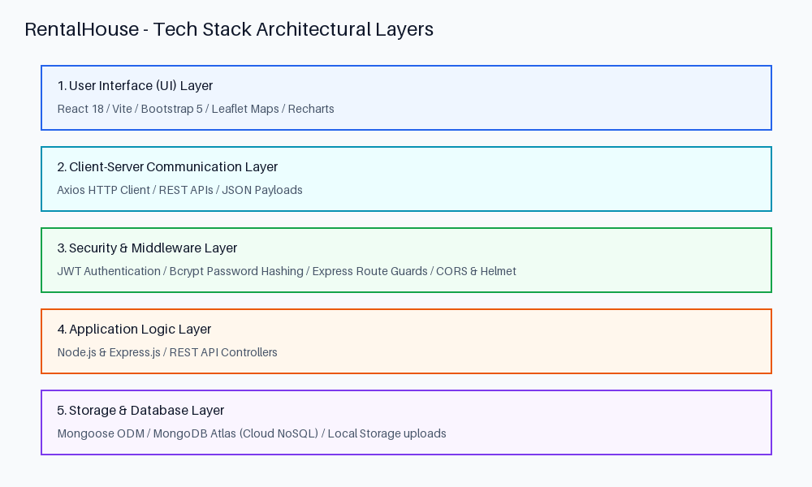
Reference: https://developer.ibm.com/patterns/ai-powered-backend-system-for-order-processing-during-pandemics/
Guidelines:
Include all the processes (As an application logic / Technology Block)
Provide infrastructural demarcation (Local / Cloud)
Indicate external interfaces (third party API’s etc.)
Indicate Data Storage components / services
Indicate interface to machine learning models (if applicable)


Table-1 : Components & Technologies:
S.No | Component | Description | Technology
1 | User Interface Layer | Interactive Web UI for viewing properties, managing dashboards, and toggling theme states. | HTML5, Vanilla CSS3, Javascript, React 18, Vite, Bootstrap 5
2 | Application Logic Layer | REST API controller handlers for authentication, property management, reviews, and bookings. | Node.js, Express.js
3 | Object Modeling | MongoDB schema creation, modeling, validation, and querying operations. | Mongoose ODM
4 | Security Gatekeeper | Auth middleware decoding and validating authorization tokens. | jsonwebtoken (JWT) library
5 | Database | Persistent data store for users, properties, bookings, favorites, and inquiry messages. | MongoDB Atlas (Cloud Cluster)
6 | File Storage | Storage backend hosting uploaded images of properties. | Local filesystem (uploads/) / Cloudinary API
7 | External API-1 (Maps) | Map widgets loading geolocation markers of rental locations. | Leaflet / OpenStreetMap API
8 | External API-2 (Emails) | Sends visit scheduling approvals or inquiry notifications. | Nodemailer (Ethereal SMTP fallback)
9 | Infrastructure / Server | Web application deployment and backend hosting server environment. | Render (Backend Server) / Vercel (Frontend Client)

Table-2: Application Characteristics:
S.No | Characteristics | Description | Technology
1 | Open-Source Frameworks | Decoupled React client communicating with a custom Express backend API using standard JSON payloads. | React 18, Node.js, Express.js, Mongoose
2 | Security Implementations | Route guards restricting access to Dashboards, Bcrypt hashing on user passwords, token authentication headers. | Bcrypt.js, JWT, Helmet, CORS
3 | Scalable Architecture | Three-tier architecture isolating UI from backend logic and cloud database. Scalable database replica sets. | 3-Tier Stateless MVC, MongoDB Atlas
4 | Availability | Continuous integration deployment pipelines with automatic load balancing and fallback nodes. | Render & Vercel deployment
5 | Performance | Fast local asset compilations, fast properties listing loads, indexed queries for location fields. | Vite builder, MongoDB indexes, Express Compression

References:
https://c4model.com/
https://developer.ibm.com/patterns/online-order-processing-system-during-pandemic/
https://www.ibm.com/cloud/architecture
https://aws.amazon.com/architecture
https://medium.com/the-internal-startup/how-to-draw-useful-technical-architecture-diagrams-2d20c9fda90d

